**Mycobacterial CRISPRi Primer Designer**

I. Description

This is a program designed to facilitate the creation of primers for CRISPR interference in *Mycobacteria*. It uses the primer design guidelines set forth in Rock et al. *Nat Micr* (2017) to build forward and reverse primers that anneal each other and have overhangs suited for cloning into BsmBI-linearized pJR962. In brief, the algorithm works as follows:

- search the user-input coding sequence for each of the strong PAM sites outlined in the paper

- for each strong PAM site found, if it is far enough from the end of the gene to actually design primers against, it will design the primers

- if no strong PAM sites are found, it gives the user the option to look for weaker PAM sites and design primers for those

- if no weak PAM sites are found, it reports that the input sequence cannot be knocked down using this exact technique

In addition to designing CRISPRi primers, the program can design primers for CRISPR. In practice, for the user, this is as simple as selecting a check button in the UI. For the program, this adds additional steps, such as:

- reverse complement the input coding sequence to create a template sequence

- if no strong PAM sites are found in either coding or template sequences, the user may again opt to search for weaker PAM sites (this time in both sequences)

- if no weak PAM sites are found, it reports that the input sequence cannot be targeted by CRISPR on either strand

As this program is merely a tool designed to speed up the process of designing CRISPR(i) sgRNA primers (primarily by finding the PAM sites for you), you should always check the primers returned against your sequence (i.e. using CLC Genomics Workbench) to verify that they make sense and are likely to achieve your desired knockdown/knockout.

Any bugs encountered should be reported as soon as possible. This can be done either by creating an issue on Github (<https://www.github.com/chg60/crispri/>issues) or by emailing Christian directly at [chg60@pitt.edu](mailto:chg60@pitt.edu) with “Mycobacterial CRISPRi Primer Designer – Bug” in the subject line. Regardless of reporting method, please be sure to include a description of the application behavior, the name you gave your sequence, the coding sequence you entered, the program version number, and indicate whether the CRISPR box was checked and whether a save file was selected.

Please feel free to also send along suggestions for added functionality.

II. Guided Example

Upon double-clicking the application, a window should launch closely resembling the following:



The top entry box is there for you to name your sequence. It is strongly recommended that you give your sequence a name if you plan to save any primers to a file. My personal preference is to use whatever the gene name is. For example, if I’m knocking down gene 30 from Mycobacterium phage MichelleMyBell, I would name it MMB30 in the program.



The middle entry box is there for you to paste or type the *coding* sequence of your gene/region of interest. This is important because the CRISPRi system described in Rock et al. *Nat Micr* (2017) is strand-specific.

The check button allows you to search in a non-strand-specific manner, should you require primers for CRISPR, rather than CRISPRi.

The “Choose save file” button is present for users that like to keep everything neatly documented and don’t want to copy and paste everything themselves. While users are not required to choose a save file, the program will prompt you to confirm that you want to proceed, should you choose to “Run Program” without choosing a save file. Clicking the “Choose save file” button will result in a low profile save file window such as this one,

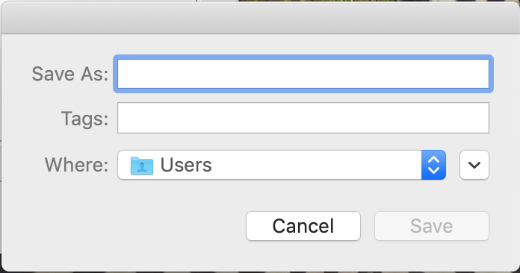

which can be expanded by clicking on the button with the upside-down ^ symbol, above the save button. Doing so will result in a window resembling this one,



where you can more easily navigate to the folder you’d like the output file stored to, enter a name for the file in the “Save As” field, and click “Save”. Clicking “Cancel” at this point will eliminate any save file name/location you may have began to select.

If you decided not to save the output to a file, clicking on the “Run Program” button will pop up a notification asking whether you want to proceed despite not having a save file selected. You can choose “Cancel” or “No” to go back and choose a save file. Clicking “Yes” will tell the program to run anyway.



If you run the program, it will search for strong PAM sites in your sequence (or sequence and reverse complement in CRISPR mode). If any are found, it will generate primers and display them. If you opted to save to a file, the primers will be saved there as well.



If no strong primers are found, you’ll be notified, and asked if you’d like the program to try looking for weaker PAM sites and generating primers for those.



If you choose yes and the program succeeds in finding weak PAM sites, you’ll get a similar output to the above successful outcome. Otherwise, you’ll get a message indicating that your sequence can’t be knocked down/out using this method.

III. Documentation

The documentation can be found by clicking Help > Documentation. It will launch a Preview window with displaying a .pdf formatted copy of this document. This document is revised with each update, and was last revised on 3/27/19.

IV. Bugs and Comments

Developing applications is non-trivial, especially when one has other (non-coding) duties to attend to. With that in mind, I am sure that there will be bugs left undiscovered which will be found by someone downstream. In that event, please email me (Christian) at [chg60@pitt.edu](mailto:chg60@pitt.edu), with “Mycobacterial CRISPRi Primer Designer Bug” in the subject line, or open an issue at <https://www.github.com/chg60/crispri/issues>. In either case, please do your best to give a detailed description of what happened, and what inputs were used to get it (name given to the sequence, the sequence itself, whether the CRISPR box was checked, save file location if you indicated one, and the version number, obtainable by clicking Help > Report a Bug in the application). I will do my best to address any bugs discovered in a timely fashion, and push updates to Github ASAP.

If there are features you think would be useful for me to add in a later version, please email me (Christian) at [chg60@pitt.edu](mailto:chg60@pitt.edu), with “Mycobacterial CRISPRi Primer Designer – Suggestion” in the subject line. In this case it would be useful to have as detailed a description of the tool(s) you’d like added as possible. Again, I will address these and push updates to Github ASAP.

I’m still looking for a good image to use as an application icon, so if you come up with one for which there would be no licensing/copyright issues, please let me know, and I’ll consider using it.

V. Updates

Updates will be available at Github and can be downloaded there directly. Alternatively, if you launch the application, there is a built in tool under Help > Check for Updates, which *should* be able to check for updates and download them if they’re available. This is a new feature to me, so we’ll see how well it works long-term.